Purpose:
The purpose of this design is to define a metadata-driven KPI framework where KPI logic, business definitions, ownership, and downstream configuration are managed centrally.
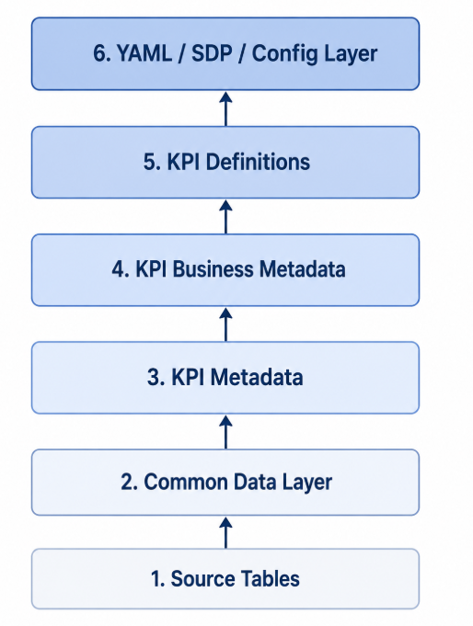
This design allows the organization to define KPIs once and reuse them across Power BI, semantic models, data products, APIs, dbt, documentation, and data quality processes.

Problem Statement:
Currently, KPI logic is often defined separately across reports, SQL queries, dashboards, Excel files, semantic models, and business documentation.

Issue | Impact
Duplicate KPI logic | Same KPI may produce different results in different reports
Hardcoded calculations | Logic is difficult to audit and maintain
No central business definition | Business users may interpret KPIs differently
Weak ownership | No clear owner for KPI approval or change management
Limited lineage | Difficult to trace KPI back to source tables and columns
Manual config maintenance | Downstream YAML / semantic model configuration requires repeated manual effort

This framework solves the issue by creating a governed KPI definition process from source data to final YAML / SDP / config output.

High-Level Architecture Diagram
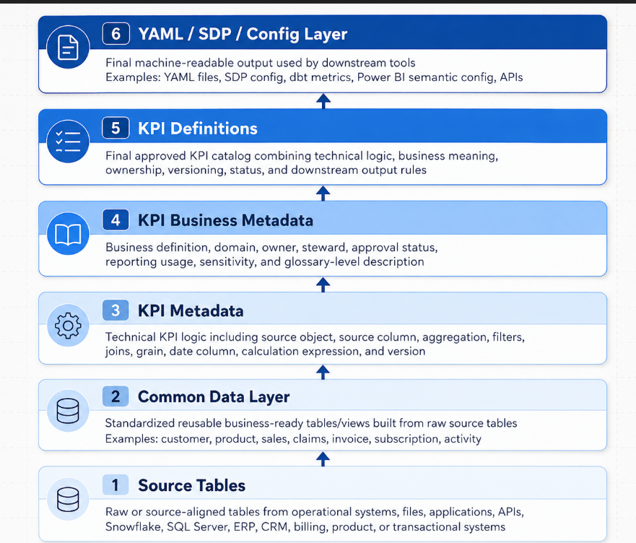

Architecture Summary
The architecture separates KPI creation into six layers.
Layer | Purpose | Main Output
Source Tables | Store raw or source-aligned data | Physical source tables
Common Data Layer | Standardize source data into reusable business objects | Common views/tables
KPI Metadata | Capture technical calculation logic | Technical KPI records
KPI Business Metadata | Capture business meaning and ownership | Business glossary records
KPI Definitions | Combine approved technical and business metadata | Governed KPI catalog
YAML / SDP / Config Layer | Generate downstream configuration | YAML, SDP, semantic config

Detailed Layer Design
Source Tables
Source tables are the original data objects used for reporting and KPI calculation. These can come from transactional systems, application databases, ERP systems, CRM systems, billing platforms, flat files, APIs, or third-party feeds.
Responsibility | Description
Store source-aligned data | Data should remain close to the source structure
Preserve source lineage | Source table and column names should be traceable
Support downstream standardization | Source tables feed the Common Data Layer
Avoid KPI logic | KPI calculations should not be directly embedded in this layer

Source tables should not become the primary KPI calculation layer. They should feed the Common Data Layer, where reusable business-ready objects are created.
Common Data Layer
The Common Data Layer standardizes source data into clean, reusable, business-ready tables or views.
This layer acts as the stable contract between raw source data and KPI definitions

Responsibilities:
Responsibility | Description
Standardize naming | Convert source-specific column names into consistent business-friendly names
Normalize data types | Standardize dates, numeric fields, flags, and identifiers
Apply reusable joins | Join commonly required lookup/reference tables
Define grain | Establish whether data is daily, monthly, customer-level, product-level, transaction-level, etc.
Clean source inconsistencies | Handle nulls, duplicate handling, invalid values, and reusable filters
Support KPI reuse | Provide stable objects for KPI metadata to reference

Common Data Layer Design Principles
Principle | Explanation
Stable contract | KPI definitions should point to common views/tables, not volatile source objects
Reusable logic | Common joins and cleansing should be handled once
Business-aligned grain | Every common object should have a clearly documented grain
Minimal KPI logic | This layer can standardize data, but final KPI calculations should remain metadata-driven

KPI Metadata
KPI Metadata stores the technical definition of how a KPI is calculated.
This layer answers the question: How is this KPI calculated technically?

Core Attributes
Column | Description
kpi_id | Unique identifier for the KPI
kpi_name | Technical KPI name
source_object | Common layer object used for calculation
source_column | Column used for the measure
aggregation_type | SUM, COUNT, AVG, MIN, MAX, DISTINCT_COUNT
calculation_expression | SQL or metric expression
filter_condition | KPI-specific filter
join_condition | Required join condition, if applicable
date_column | Date field used for time-based reporting
grain | KPI reporting grain
version_number | KPI version
is_active | Active/inactive flag

KPI Business Metadata
KPI Business Metadata stores the business meaning, owner, domain, approval status, and reporting context.
This layer answers the question: What does this KPI mean to the business?

Column | Description
kpi_id | Links business metadata to technical KPI metadata
business_kpi_name | Business-friendly KPI name
business_definition | Plain-English definition
business_domain | Business domain such as Sales, Finance, Claims, Product, Operations
business_owner | Owner responsible for KPI sign-off
data_steward | Person/team responsible for data quality
reporting_usage | Reports, dashboards, or products using the KPI
approval_status | Draft, Under Review, Approved, Deprecated
sensitivity_level | Public, Internal, Confidential, Restricted
calculation_notes | Additional business rules or exceptions

KPI Definitions
KPI Definitions are the final governed KPI catalog created by combining technical KPI metadata and business KPI metadata.
This layer becomes the trusted source for downstream consumption.
KPI Definition Logic
KPI Definition =
Technical KPI Metadata
+ Business KPI Metadata
+ Approval Status
+ Version
+ Ownership
+ Output Rules

YAML / SDP / Config Layer
The YAML / SDP / Config Layer generates machine-readable configuration from approved KPI definitions.
This layer allows downstream tools to consume KPI definitions consistently.

Output Type | Usage
YAML Config | Stores KPI definitions in a reusable file format
SDP Config | Defines Semantic Data Product structure
dbt Metrics | Enables metrics-as-code
Power BI Semantic Config | Supports consistent semantic model creation
API Config | Enables KPI exposure through APIs
Data Quality Config | Creates validation rules from KPI definitions
Documentation Config | Generates business glossary and KPI catalog pages

Example YAML Output
kpi_id: KPI_001
technical_name: total_completed_sales
business_name: Total Completed Sales
description: Total sales amount for completed orders only
domain: Sales
owner: Sales Analytics Team
data_steward: Data Engineering Team
source:
object: COMMON.VW_SALES
column: sales_amount
calculation:
aggregation: SUM
expression: SUM(sales_amount)
filters:
- order_status = 'COMPLETED'
grain: daily
date_column: order_date
approval_status: approved
version: 1
sensitivity: internal

Example SDP Config
semantic_data_product:
name: sales_performance_sdp
domain: Sales
owner: Sales Analytics Team
description: Governed semantic data product for sales performance KPIs

datasets:
- name: common_sales
source_object: COMMON.VW_SALES
grain: daily
date_column: order_date

metrics:
- kpi_id: KPI_001
name: total_completed_sales
business_name: Total Completed Sales
expression: SUM(sales_amount)
filters:
- order_status = 'COMPLETED'
owner: Sales Analytics Team
approval_status: approved

Process Flow Diagram
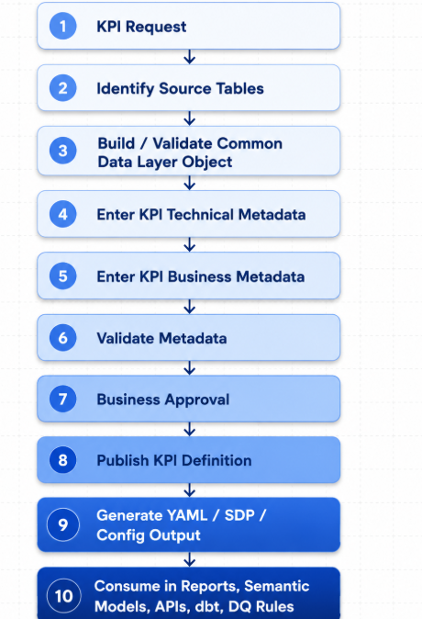

Roadmap
Phase 1: Discovery and Current-State Assessment
Understand the existing KPI landscape, source tables, reports, and business definitions.
Activity | Description
Identify source tables | List all source tables currently used for KPI reporting
Identify reports | Capture Power BI reports, dashboards, Excel trackers, SQL extracts, and existing semantic models
Extract KPI logic | Review DAX, SQL, stored procedures, report measures, and manual calculations
Identify duplicate KPIs | Find KPIs with same name but different calculation logic
Identify owners | Map KPIs to business owners and technical owners
Capture pain points | Document inconsistencies, missing definitions, and quality issues

Deliverable | Description
Source inventory | Source tables and columns used for KPI reporting
KPI inventory | Existing KPI names, calculations, and report usage
Duplicate KPI list | KPIs with conflicting definitions
Owner mapping | Business and technical owners
Initial gap analysis | Missing metadata, unclear logic, or undefined ownership

Phase 2: Common Data Layer Design
Build standardized reusable data objects that KPI metadata can reference.
Activity | Description
Define common entities | Customer, Product, Sales, Invoice, Claims, Activity, etc.
Create common views/tables | Build reusable objects from source tables
Standardize column names | Use consistent names across domains
Define grain | Document each object’s level of detail
Validate counts | Compare common layer counts with source tables
Document lineage | Map source columns to common layer columns

Deliverable | Description
Common layer objects | Views or tables under COMMON schema
Source-to-common mapping | Column-level mapping document
Grain documentation | Grain for each common object
Validation queries | Count checks, duplicate checks, null checks

Phase 3: KPI Metadata Model Build
Create the technical metadata model for KPI calculations.
Activity | Description
Create KPI metadata table | Build GOV.KPI_METADATA
Define supported aggregation types | SUM, AVG, COUNT, DISTINCT_COUNT, MIN, MAX
Define expression standards | Standard format for SQL or metric expressions
Define filter standards | Standard format for filter conditions
Add versioning | Add version number and active flag
Load initial KPI metadata | Populate technical KPI records

Deliverable | Description
KPI metadata table | Stores technical KPI logic
Data dictionary | Defines each metadata field
Initial KPI technical load | Initial KPI records loaded
Metadata quality checks | Queries to validate metadata completeness

Phase 4: KPI Business Metadata Build
Capture business meaning, ownership, and approval workflow.
Activity | Description
Create business metadata table | Build GOV.KPI_BUSINESS_METADATA
Add business definitions | Plain-English KPI definitions
Assign owners | Business owner and data steward
Add approval status | Draft, Review, Approved, Deprecated
Add domain mapping | Sales, Finance, Operations, Claims, Product, etc.
Add sensitivity level | Internal, Confidential, Restricted, etc.

Deliverable | Description
Business metadata table | Stores KPI business context
KPI glossary | Business-friendly KPI definitions
Approval workflow | Status management process
Owner matrix | Owner and steward mapping

Phase 5: KPI Definition Catalog
Combine technical and business metadata into an approved KPI catalog.
Activity | Description
Create KPI definition view | Build GOV.VW_KPI_DEFINITIONS
Join metadata layers | Combine technical and business metadata
Filter approved KPIs | Only publish active and approved KPIs
Add validation results | Include readiness or validation status
Add usage mapping | Track downstream report/product usage

Deliverable | Description
KPI definition view | Final approved KPI catalog
Published KPI list | Approved KPIs available for use
Version history | KPI changes by version
Usage mapping | Where each KPI is consumed

Phase 6: YAML / SDP / Config Generation
Generate downstream configuration files from approved KPI definitions.
Activity | Description
Define YAML schema | Standard structure for KPI config
Build generation script | Read approved KPI definitions and generate YAML
Validate generated YAML | Ensure required fields exist
Store in Git | Version-control generated config
Integrate downstream tools | Use config for semantic models, dbt, APIs, docs, and DQ rules

Deliverable | Description
YAML schema | Approved config structure
Generated YAML files | KPI config by domain or product
SDP config | Semantic data product configuration
Validation script | Checks YAML completeness and format
Git repository | Version-controlled config files

Phase 7: Reporting and Semantic Layer Integration
Use approved KPI definitions in downstream reporting and semantic products.
Activity | Description
Map KPIs to Power BI | Align KPI definitions with Power BI measures
Map KPIs to semantic model | Build reusable semantic layer definitions
Map KPIs to dbt metrics | Generate metrics-as-code where applicable
Validate report values | Compare generated KPI values with existing trusted reports
Publish documentation | Expose KPI definitions to business users

Deliverable | Description
Power BI mapping | KPI-to-measure mapping
Semantic model config | Metric definitions for semantic layer
Report validation | KPI result comparison
Published KPI catalog | Business-facing documentation

Phase 8: Governance and Change Management
Ensure KPI changes are controlled, approved, versioned, and auditable.
Activity | Description
Define approval workflow | Technical review and business approval
Add audit logging | Track changes to KPI metadata
Add version history | Preserve previous calculation logic
Define deprecation process | Retire old KPIs safely
Track usage | Identify reports/products impacted by KPI changes
Monitor quality | Validate KPI output regularly

Deliverable | Description
KPI governance process | Creation, approval, change, deprecation
Audit tables | Track metadata changes
Version history | Preserve old KPI versions
Impact analysis | Downstream usage tracking
Data quality checks | Ongoing KPI validation

